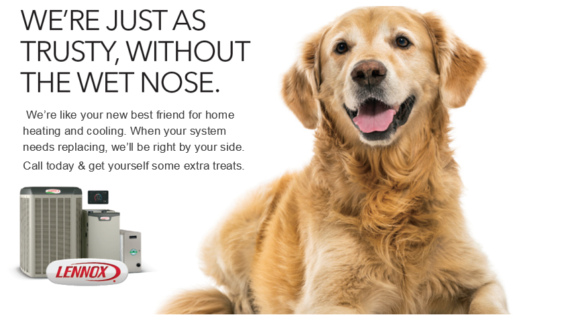

GET REBATES OF UP TO $1,700* ON A QUALIFYING LENNOX® HOME COMFORT SYSTEM.
The Dave Lennox Signature® Collection is the ultimate expression of Lennox® innovation, and that makes it the perfect choice for your home. Each product is a standout on its own, leading the market in efficiency, quiet operation and comfort. Working together in one system, they create an environment of perfectly heated and cooled air.
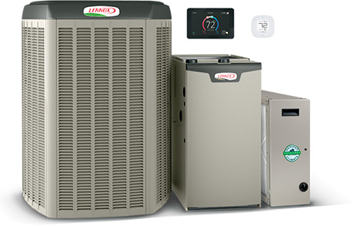
START WITH UP TO $1,400 IN REBATES.*
Save on a complete qualifying Lennox® home comfort system that includes
air conditioner or heat pump, gas furnace or air handler and thermostat.

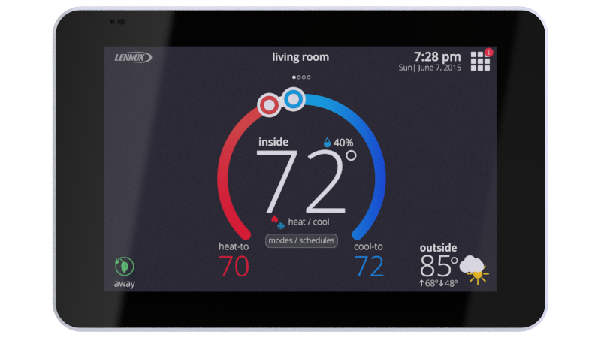
GET UP TO A $100 REBATE ON a WI-FI THERMOSTAT.*
With the Schedule IQ feature, you only need to program the thermostat once. Whenever there's a change in your routine, the iComfort S30 adapts heating and cooling to match.

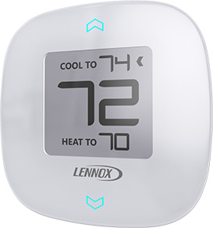
GET UP TO A $100 REBATE ON ZONING.*
Purchase iHarmony® zoning, a major advance in precision climate
control and Enjoy savings and custom comfort.

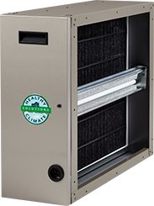
GET UP TO A $100 REBATE ON pUREAIR.*
Cleans the air in your home better than any other single system you can buy, doesn’t
produce ozone and that means cleaner air in every room.

WANT MORE? GET UP TO AN ADDITIONAL $500 in tax credits**
ENERGY STAR products eligible for tax credits are independently certified to save energy,
save money and protect the environment.



--OR-- SPECIAL FINANCING OFFERS THAT ARE

EQUALLY REWARDING.

NO PAYMENTS AND NO INTEREST UNTIL 2017***

OR

PAYMENTS AS LOW AS $97 A MONTH****

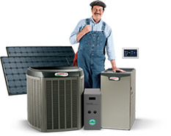
Take the next step & CALL for details.

Your family’s health, comfort and safety is our business.
Our comfort advisors would be happy to answer any and
all of your questions. Call us today so we can help you
achieve total home comfort.

*Some restrictions apply. System rebate offers range from $150–$1,700. Rebate offer is valid March 21, 2016 through June 10, 2016 with the purchase of qualifying Lennox products. Cannot be combined with any other offer. Additional add–on rebates for iComfort® S30 Thermostat, iHarmony® Zoning System and PureAir™ Air Purification system valid with a qualifying system purchase only. See your participating Lennox dealer for complete details.
**Visit www.energystar.gov/taxcredits for minimum requirements.
***Financing offers a no payment - no interest feature (during the "promotional period") on your purchase at an APR of 0.0%. No finance charges will accrue on your account during the promotional period, as set forth in your Truth in Lending Disclosures, and you will not have to pay a monthly payment until the promotional period has ended. If you repay your purchase in full before the end of the promotional period you will not have to pay any finance charges. You may also prepay your account at any time without penalty. Financing is subject to credit requirements and satisfactory completion of finance documents. Any finance terms advertised are estimates only. Normal late charges apply once the promotional period has ended. See your Truth in Lending Disclosures for more information.

****Based on qualifying system cost of $8000 at 7.99% APR for ten years. Financing available to well qualified buyers on approved credit at an APR of 7.99% for 120 months, with an estimated monthly payment of 1.21% of your purchase amount. You may prepay your account at any time without penalty. Financing is subject to credit requirements and satisfactory completion of finance documents. Any finance terms advertised are estimates only. Normal late charges apply. See your Truth in Lending Disclosures for more information.

